Nama :Iqbal Subekhan

NIM : 18090006

Kelas : 5A

**PRAKTIKUM 1**

1. Source Code

Perkenalin.php -> application/controller

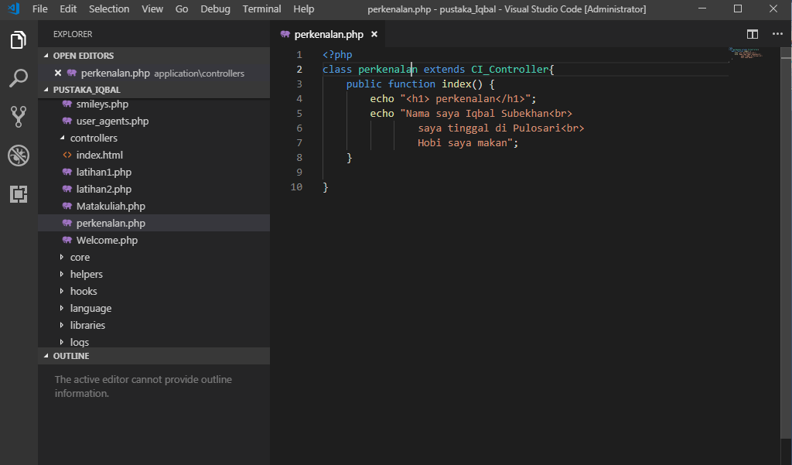

1. URL

<http://localhost/pustaka_Iqbal/index.php/perkenalan>

1. Capture Hasil

